**Localisation Lab Help Printscreens**

Eclipse (on Windows) has an issue showing Russian and Chinese characters that Netbeans (on my Mac) does not. To get exercise 15-1 working:

* right-click on the properties of the Project
* change the encoding style to UTF-8

See screenshot below:

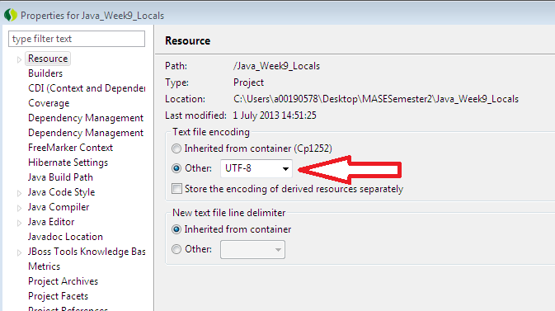

**Creating a properties file:**

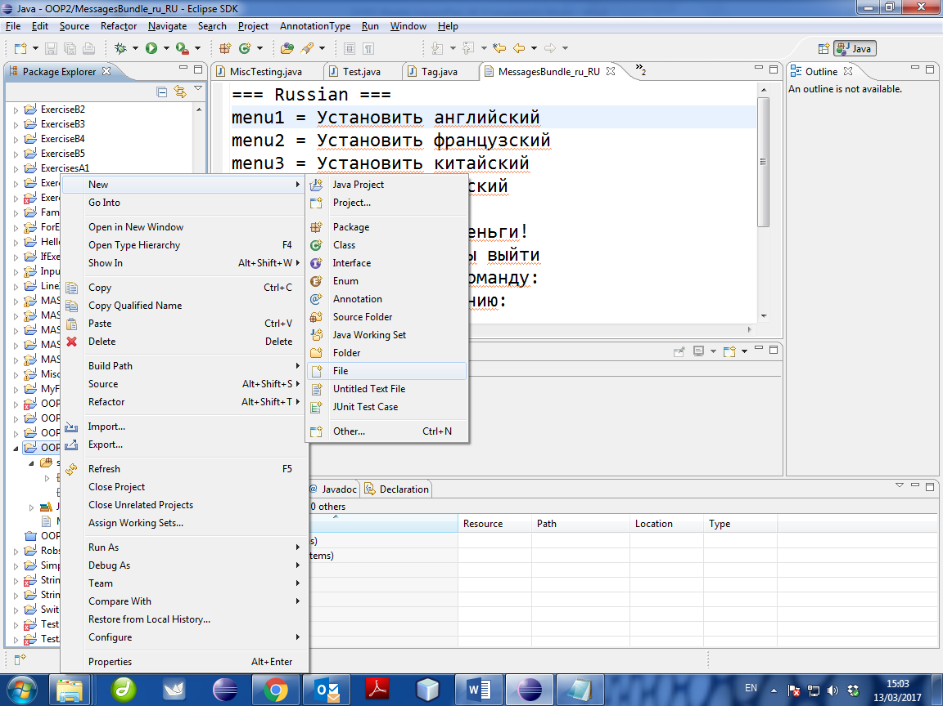

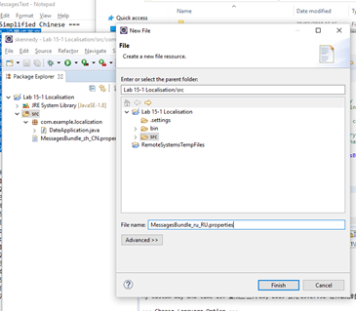

1. Make sure “src” folder is the target (this auto copies the files into the “bin” folder at runtime (so they will be found). As this is the root of “src”, look for “MessagesBundle” and not   
   “com.example.localization.MessagesBundle”.
2. Ensure “.properties” suffix.

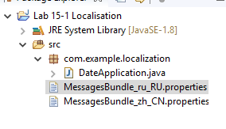 **(View in Eclipse)**

**Directories on filesystem:**

Russian and Chinese properties files are CREATED (not copied into) in the “src” folder (and because they are created, they are therefore copied into the “bin” folder).

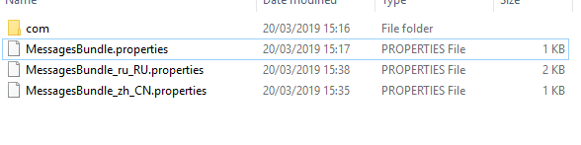

For comparison purposes, I copied the (given) French properties file into the bin/com/example/localization folder. Note the difference in the Java code (next page)

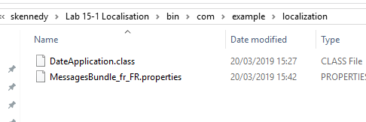

**Java code:**

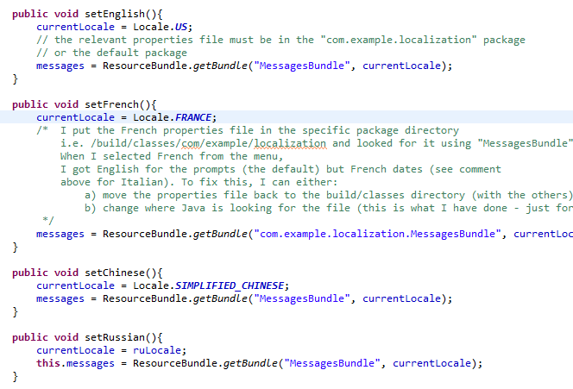

In order for the French properties file to be located in the sub directory tree structure (based on the package name), I had to include the package name before MessagesBundle. Note that the **other** properties files were in the root of src.